<*VU Name & Logo*>

*<R logo, below, you can use it creatively*>

Online Training Programme on

<*title, so use big font main highlight*> R FOR BEGINNERS

<*subtitle*> An Introduction to Data Science using R

Organized by: Department of Travel & Tourism, Faculty of Humanities & Social Sciences

24th to 29th Jan. 2022, 4:00 PM to 6:00 PM (IST)

Fee: Rs. 499 per Participant | No Charges for Vishwakarma University Members

5 Live Sessions - 2 hrs each | E-Certificates | Google Meet

Last date of registration: 21st Jan. 2022

Resource Person

Dr Ajay Kumar Koli <use below picture>

Assistant Professor, Vishwakarma University – Pune

*<LI icon>* https://www.linkedin.com/in/ajay-kumar-koli/

Training modules:

* R & RStudio Basics
* Dynamic Documents
* Data Visualisation
* Data Wrangling
* HTML Slides

|  |  |  |  |
| --- | --- | --- | --- |
| **Chief Patron**  Dr Chetan Kapadnis  Prof & Dean  Faculty of Humanities & Social Sciences | **Convenor**  Prof Aarti Suryawanshi Head of Department  Department of Travel & Tourism | **Coordinator**  Prof Remi J. Thomas  remi.thomas@vupune.ac.in  Department of Travel &  Tourism | *<place QR codes for payment and registration form here>* |

Registration form link: <https://forms.gle/UhZ44QoPCL4hqHYm6>



R logo



Resource person picture

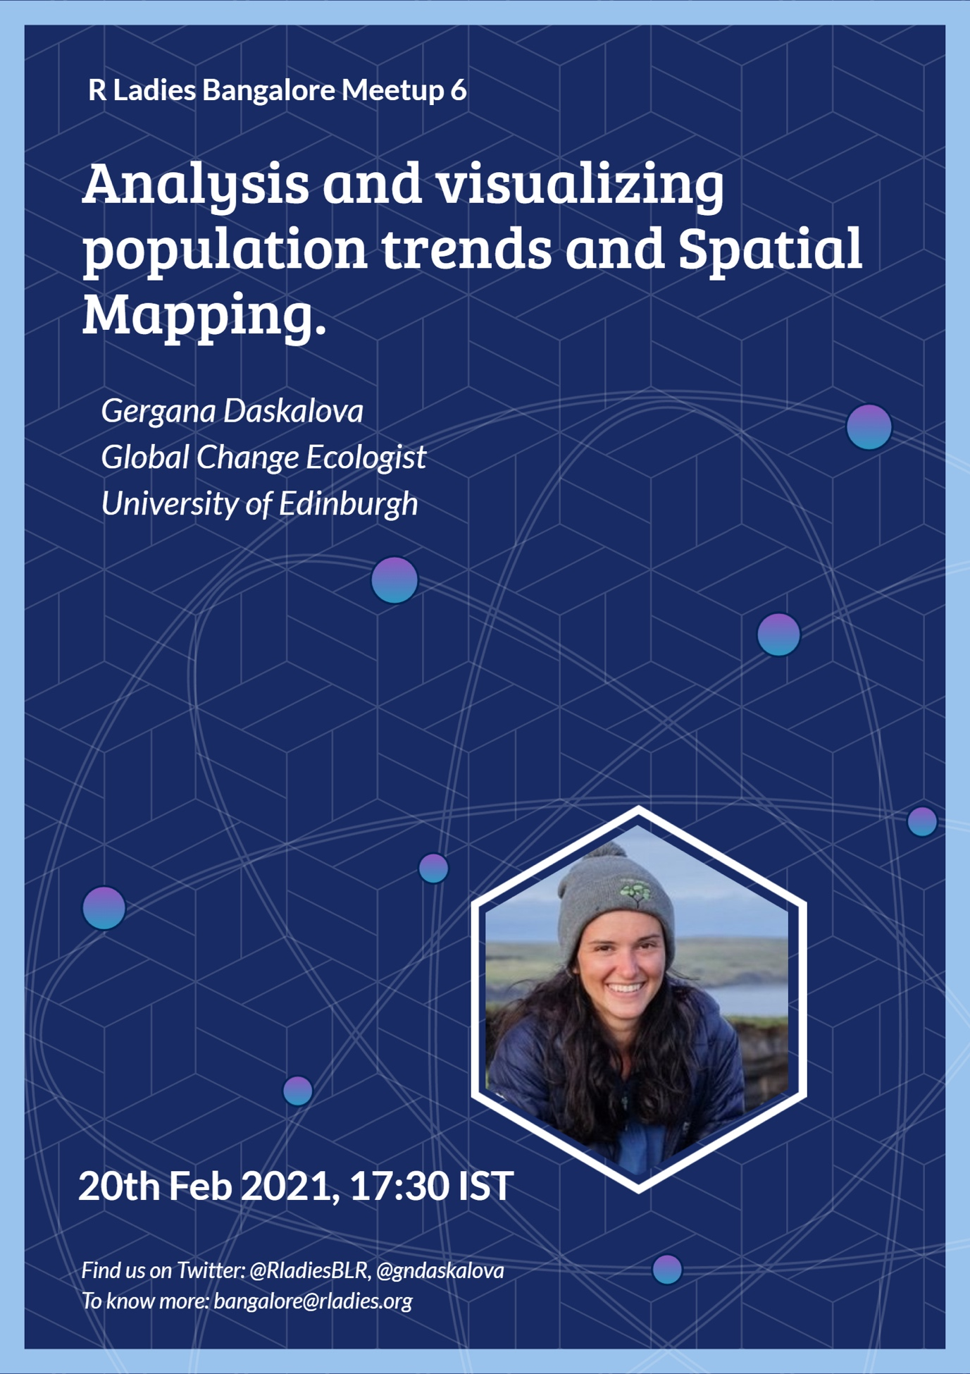sample flyer 1

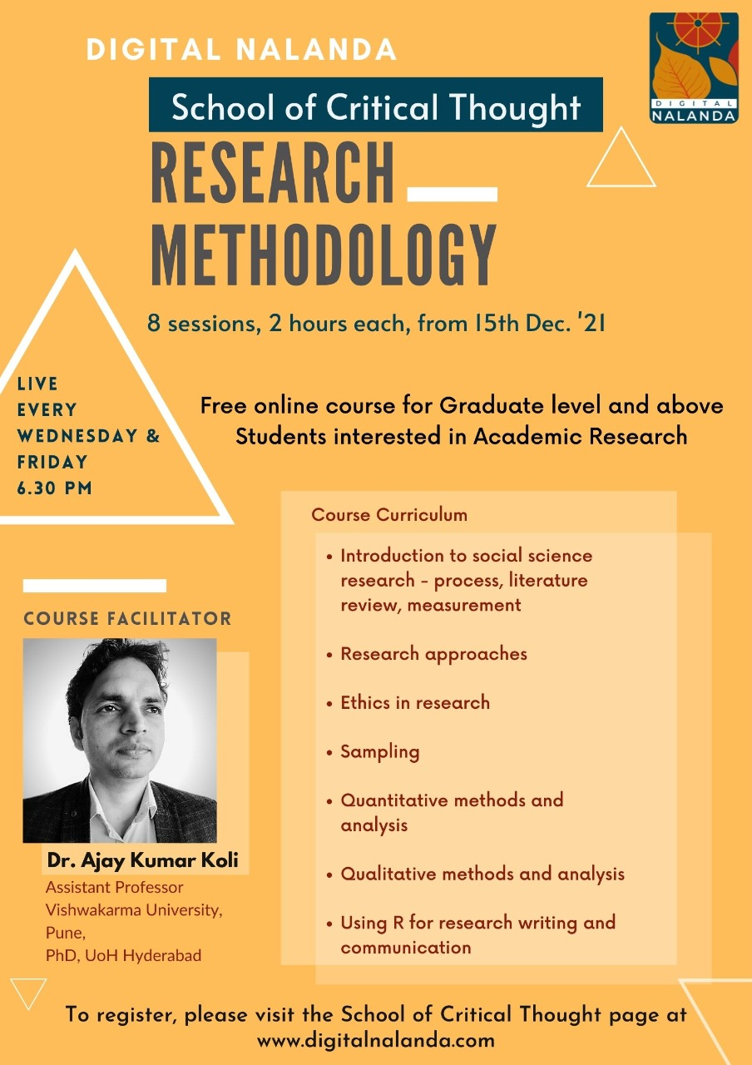

Sample flyer 2

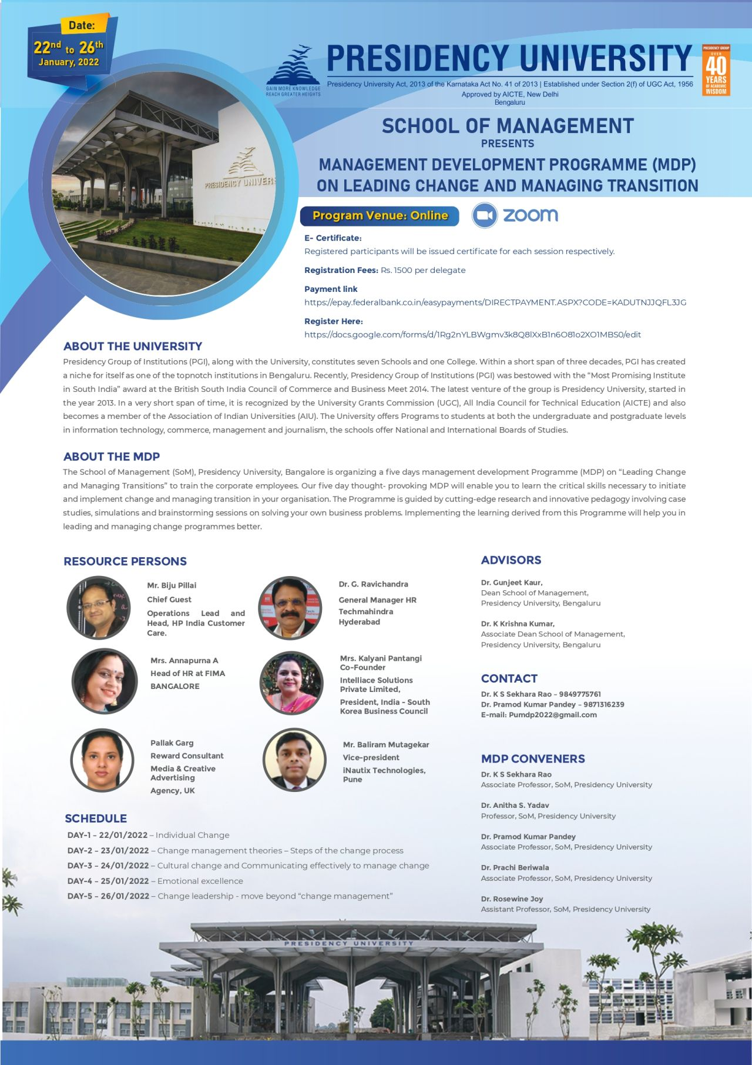

Sample flyer 3